***MÉTODO DE BISECCIÓN***

function [ raiz, t ] = biseccion( min,max,tol )

%METODO DE BISECCION

format long

format compact

syms x;

y=x^5-4*x^3+x+1; %modificar para otras funciones

if ((subs(y,x,min)<0&&subs(y,x,max)>0)||(subs(y,x,min)>0&&subs(y,x,max)<0))

a=[];

b=[];

p=[];

e=[];

if(subs(y,x,min)<0&&subs(y,x,max)>0)

a(1)=min;

b(1)=max;

else

a(1)=max;

b(1)=min;

end

p(1)=(a(1)+b(1))/2;

t=cell(1,8);

t(1,:)={'n','a','b','f(a)','f(b)','Pn','f(Pn)','Error'};

t(2,:)={1,a(1),b(1),subs(y,x,a(1)),subs(y,x,b(1)),p(1),subs(y,x,p(1)),…

'----------------------'};

i=2;

while(1)

if(subs(y,x,p(i-1))<0)

a(i)=p(i-1);

b(i)=b(i-1);

else

a(i)=a(i-1);

b(i)=p(i-1);

end

p(i) = (a(i)+b(i))/2;

e(i)=abs((p(i)-p(i-1))/p(i));

t(i+1,:)={i,a(i),b(i),subs(y,x,a(i)),subs(y,x,b(i)),p(i),subs(y,x,p(i)),e(i)};

if(e(i)<tol),break; end;

i=i+1;

end

raiz=p(i);

else

disp('No hay raices en el intervalo')

raiz=[];

t=[];

end

end

***Tabla de resultados:***

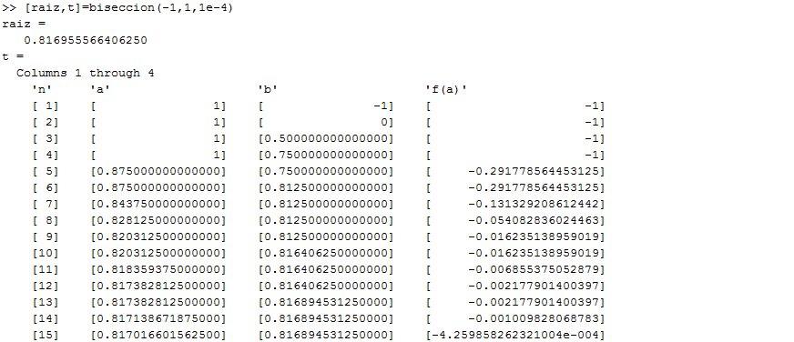

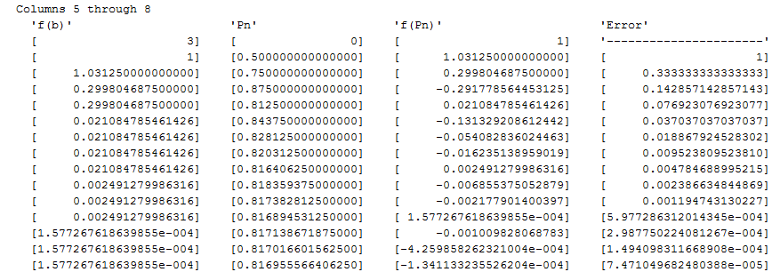

***MÉTODO DE PUNTO FIJO***

function [ raiz,t ] = pfijo( min,max,tol )

%METODO DE PUNTO FIJO

format long

format compact

syms x;

y=x^3-24; %Modificar para otras funciones

dy=diff(y,x);

g=x-y/dy;

if(subs(g,x,min)<=max&&subs(g,x,min)>=min&&subs(g,x,max)>=min&&subs(g,x,max)<=max)

p=[];

e=[];

p(1)=max;

t=cell(1,4);

t(1,:)={'n','Xn','f(Xn)','Error'};

t(2,:)={1,p(1),subs(g,x,p(1)),'----------------------'};

i=2;

while (1)

p(i) = subs(g,x,p(i-1));

e(i) = abs((p(i)-p(i-1))/p(i));

t(i+1,:)={i,p(i),subs(g,x,p(i)),e(i)};

if(e(i)<tol),break; end;

i=i+1;

end

raiz=p(i);

else

disp('No es posible utilizar g(x) en ese intervalo');

raiz=[];

t=[];

end

end

***Tabla de resultados:***

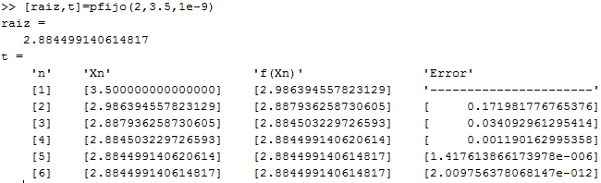

***MÉTODO DE NEWTON RAPSON***

function [ raiz,t ] = newtonraphson( min,max,tol )

%METODO DE NEWTON-RAPHSON

format long

format compact

syms x;

y=x^5-4*x^3+x+1; %Modificar para otras funciones

dy=diff(y,x);

[Xo,t]=biseccion(min,max,1e-2);

if (Xo==0||Xo)

[i,a]=size(t);

t(i,3)={'Aproximacion de Xo'};

p=[];

e=[];

p(i-1)=cell2mat(t(i,6));

e(i-1)=cell2mat(t(i,8));

if (tol<e(i-1))

while (1)

p(i) = p(i-1) - subs(y,x,p(i-1))/subs(dy,x,p(i-1));

e(i) = abs((p(i)-p(i-1))/p(i));

t(i+1,:)={i,'------------------','------------------',…

'------------------','------------------',p(i),subs(y,x,p(i)),e(i)};

if(e(i)<tol),break; end;

i=i+1;

end

raiz=p(i);

else

raiz=Xo;

end

else

raiz=[];

end

end

***Tabla de resultados:***

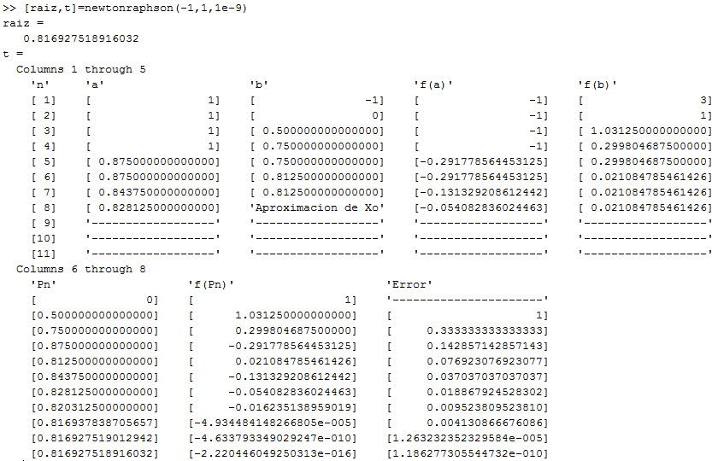

***MÉTODO DE SECANTE***

function [ raiz,t ] = metsecante( min,max,tol )

%METODO DE SECANTE

format long

format compact

syms x;

y=x^5-4*x^3+x+1; %Modificar para otras funciones

[Xo,t]=biseccion(min,max,1e-2);

if (Xo)

[i,a]=size(t);

t(i,3)={'Aproximacion de Xo'};

p=[];

e=[];

p(i-1)=cell2mat(t(i,6));

p(i-2)=cell2mat(t(i-1,6));

e(i-1)=cell2mat(t(i,8));

if (tol<e(i-1))

while (1)

p(i) = p(i-1) - subs(y,x,p(i-1))*(p(i-2)-p(i-1))/(subs(y,x,p(i-2))-subs(y,x,p(i-1)));

e(i) = abs((p(i)-p(i-1))/p(i));

t(i+1,:)={i,'------------------','------------------',…

'------------------','------------------',p(i),subs(y,x,p(i)),e(i)};

if(e(i)<tol),break; end;

i=i+1;

end

raiz=p(i);

else

raiz=Xo;

end

else

raiz=[];

end

end

***Tabla de resultados:***

